piadina:

1 - 265

2 - 430

3 - 610

4 – 720

(the variable shows the actual number of calories participants selected)

5) calories_day - Importance of consuming calories per day

1 - i don't know how many calories i should consume

2 - it is not at all important

3 - it is moderately important

4 - it is very important

6) calories_scone score - Guessing calories in a scone from starbucks

1 - 107 cal

2 - 315 DD 1) GPA – numerical, actual GPA–rating

2) Gender

(1 – Female

and 2 – Male)

3) Breakfast (the olparticipants are shown the following pictures and asked which one of these pictures they associate with the word “breakfast), 1 – cereal option and 2 – donut option

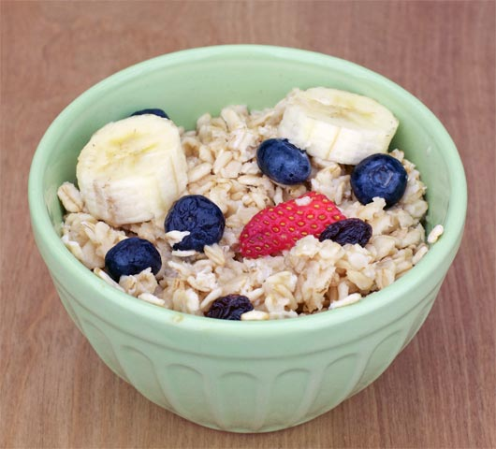

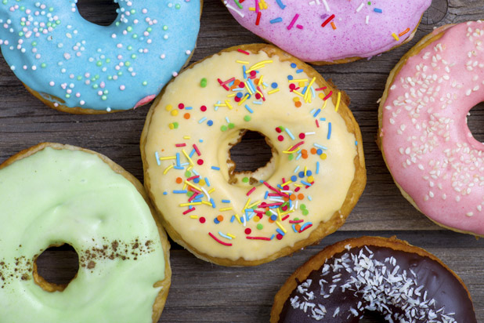

–4) calories_chicken - guessing calories in chickencal

3 - 420 cal

4 - 980 cal

(the variable shows the actual number of calories participants selected)

7) coffee – which of the two pictures you associate with the word coffee?

1 – creamy frappuccino

2 – espresso shown

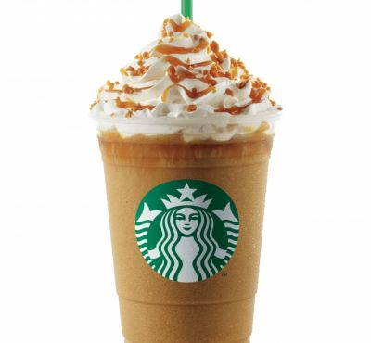

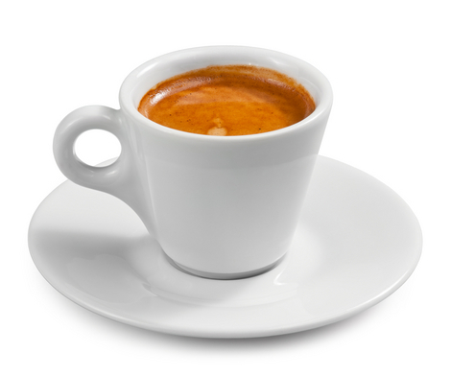

8) comfort_food - List 3-5 comfort foods that come to mind.

Open ended (perfect for NLP)

—9) comfort_food_reasons - What are some of the reasons that make you eat comfort food? (i.e., anger, sadness, happiness, boredom, etc) - list up to three

Open ended (perfect for NLP)

–10) comfort_food_reasons_coded

(the one mentioned first)

1 – stress

2 – boredom

3 – depression/sadness

4 – hunger

5 – laziness

6 – cold weather

7 – happiness

8 - watching tv

9 – none

11) cook – how often do you cook?

1 - Every day

2 - A couple of times a week

3 - Whenever I can, but that is not very often

4 - I only help a little during holidays

5 - Never, I really do not know my way around a kitchen

12) cuisine – what type of cuisine did you eat growing up?1 – American

2 – Mexican.Spanish

3 – Korean/Asian

4 – Indian

5 – American inspired international dishes

6 – other

(lots of cleaning needed for this variable)

13) diet_current – describe your current diet

open ended – ideal for NLP

14) diet_current_coded

(based on words used to describe the diet)

1 – healthy/balanced/moderated/

2 – unhealthy/cheap/too much/random/

3 – the same thing over and over

4 – unclear

15) Which picture do you associate with the word “drink”?

1 – orange juice

2 – soda

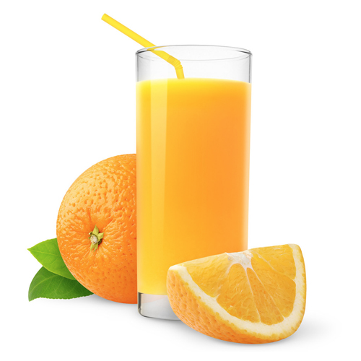

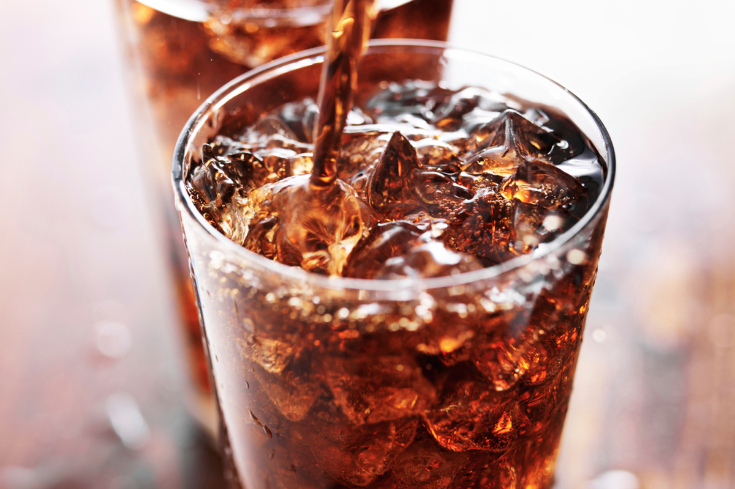

16) eating_changes - Describe your eating changes since the moment you got into college?

Open ended

17) eating_changes_coded

1 – worse

2 – better

3 – the same

4 – unclear

18) eating_changes_coded1

1 – eat faster

2 – bigger quantity

3 – worse quality

4 – same food

5 – healthier

6 – unclear

7 – drink coffee

8 – less food

9 – more sweets

10 – timing

11 – more carbs or snacking

12 – drink more water

13 – more variety

19) eating_out - frequency of eating out in a typical week

1 - Never

2 - 1-2 times

3 - 2-3 times

4 - 3-5 times

5 - every day

20) employment – do you work?

1 - yes full time

2 - yes part time

3 – no

4 - other

21) ethnic_food - How likely to eat ethnic food

1 - very unlikely

2 - unlikely

3 - neutral

4 - likely

5 - very likely

22) exercise – how often do you exercise in a regular week?

1 - Everyday

2 - Twice or three times per week

3 - Once a week

4 - Sometimes

5 – Never

23) father_education –

1 - less than high school

2 - high school degree

3 - some college degree

4 - college degree

5 - graduate degree

24) father_profession – what is your father profession?

Open ended

25) fav_cuisine - What is your favorite cuisine?

Open ended

26) fav_cuisine_coded

0-none

1 – Italian/French/greek

2 – Spanish/mexican

3 – Arabic/Turkish

4 – asian/chineses/thai/nepal

5 – American

6 – African

7 – Jamaican

8 – indian

27) fav_food - was your favorite food cooked at home or store bought?

1 - cooked at home

2 - store bought

3 - both bought at store and cooked at home

28) food_childhood – what was your favorite childhood food?

Open ended

29) which of these pictures you associate with word fries?

1 – Mcdonald’s fries

2 – home fries

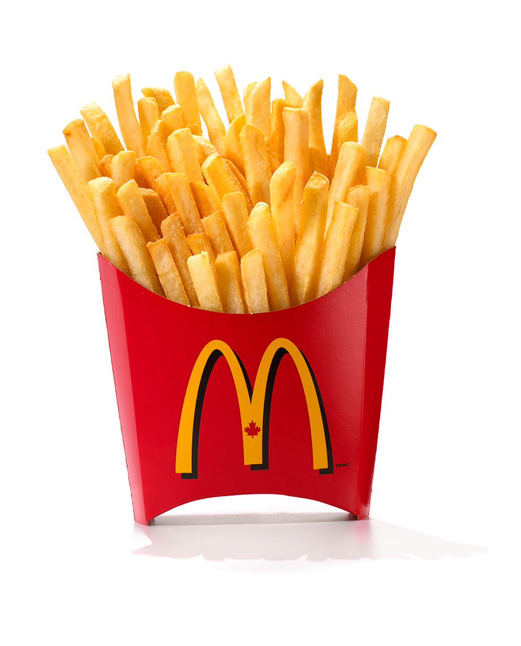

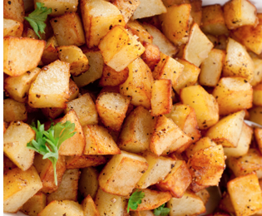

30) fruit_day - How likely to eat fruit in a regular day

1 - very unlikely

2 - unlikely

3 - neutral

4 - likely

5 - very likely

31) grade_level –

1 - freshman

2 -Sophomore

3 - Junior

4 - Senior

32) greek_food - How likely to eat greek food when available?

1 - very unlikely

2 - unlikely

3 - neutral

4 - likely

5 - very likely

33) healthy_feeling – how likely are you to agree with the following statement: “I feel very healthy!” ?

1 to 10 where 1 is strongly agree and 10 is strongly disagree - scale

34) healthy_meal – what is a healthy meal? Describe in 2-3 sentences.

Open ended

35) ideal_diet – describe your ideal diet in 2-3 sentences

Open ended

36) Ideal_diet_coded

1 – portion control

2 – adding veggies/eating healthier food/adding fruit

3 – balance

4 – less sugar

5 – home cooked/organic

6 – current diet

7 – more protein

8 – unclear

37) income

1 - less than $15,000

2 - $15,001 to $30,000 3 - $30,001 to $50,000

4 - $50,001 to $70,000

5 - $70,001 to $100,000

6 - higher than $100,000

38) indian_food – how likely are you to eat indian food when available

1 - very unlikely

2 - unlikely

3 - neutral

4 - likely

5 - very likely

39) Italian_food – how likely are you to eat Italian food when available?

1 - very unlikely

2 - unlikely

3 - neutral

4 - likely

5 - very likely

40) life_rewarding – how likely are you to agree with the following statement: “I feel life is very rewarding!” ?

1 to 10 where 1 is strongly agree and 10 is strongly disagree - scale

41) marital_status

1 -Single

2 - In a relationship

3 - Cohabiting

4 - Married

5 - Divorced

6 - Widowed

42) meals_dinner_friend – What would you serve to a friend for dinner?

Open ended

43) mother_education

1 - less than high school

2 - high school degree

3 - some college degree

4 - college degree

5 - graduate degree

44) mother_profession – what is your mother’s profession?

45) nutritional_check - checking nutritional values frequency

1 - never

2 - on certain products only

3 - very rarely

4 - on most products

5 - on everything

46) on_off_campus – living situation

1 - On campus

2 - Rent out of campus

3 - Live with my parents and commute

4 - Own my own house

47) parents_cook - Approximately how many days a week did your parents cook?

1 - Almost everyday

2 - 2-3 times a week

3 - 1-2 times a week

4 - on holidays only

5 - never

48) pay_meal_out - How much would you pay for meal out?

1 - up to $5.00

2 - $5.01 to $10.00

3 - $10.01 to $20.00

4 - $20.01 to $30.00

5 - $30.01 to $40.00

6 - more than $40.01

49) Persian_food - How likely to eat persian food when available?

1 - very unlikely

2 - unlikely

3 - neutral

4 - likely

5 - very likely

50) self_perception_weight - self perception of weight

6 - i dont think myself in these terms

5 - overweight

4 - slightly overweight

3 - just right

2 - very fit

1 - slim

51) Which of the two pictures you associate with the word soup?

1 – veggie soup

2 – creamy soup

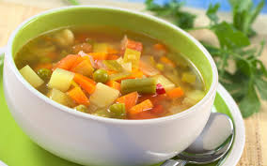

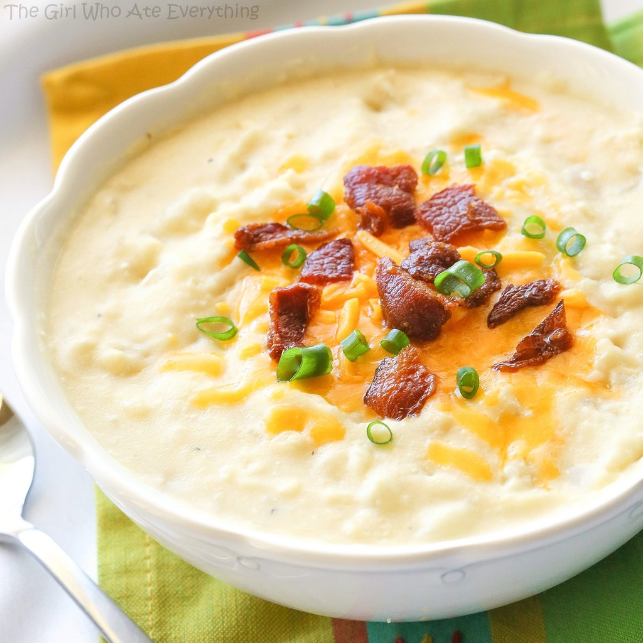

52) sports - sports – do you do any sporting activity?

1 - Yes

2 - No

99 – no answer

53) thai_food - How likely is it to eat thai food when available?

1 - very unlikely

2 - unlikely

3 - neutral

4 - likely

5 - very likely

54) tortilla_calories - guessing calories in a burrito sandwich from Chipotle?

1 - 580

2 - 725

3 - 940

4 - 1165

55) turkey_calories - Can you guess how many calories are in the foods shown below? (Panera Bread Roasted Turkey and Avocado BLT)

1 - 345

2 - 500

3 - 690

4 - 850

56) type_sports – what type of sports are you involved in?

Open-ended

57) veggies_day - How likely are you to eat veggies in a day?

1 - very unlikely

2 - unlikely

3 - neutral

4- likely

5 - very likely

58) vitamins – do you take any supplements or vitamins?

1 – yes

2 – no

59) waffle_calories - guessing calories in waffle potato sandwich

1 - 575

2 - 760

3 - 900

4 - 1315

60) weight – what is your weight in kgs

1-80-100

2-60-79

3 50-59

# Explanation of the Code and Project

## Project Workflow

### Identify Residential Locations:

The program uses the Foursquare API to fetch residential locations within a specified radius (5,000 meters) of a central point (e.g., Bengaluru city center). The residential locations are stored in a DataFrame with latitude and longitude.

### Fetch Nearby Amenities:

For each residential location, the script queries the API to count nearby amenities such as restaurants, grocery stores, and gyms within a 500-meter radius. These counts are added as additional columns in the DataFrame (Number_of_restaurants, Number_of_grocery_stores, Number_of_gyms).

### Apply K-Means Clustering:

The latitude and longitude of the residential locations are used to run the K-Means clustering algorithm. The optimal number of clusters (K) is determined by calculating the silhouette scores for a range of K values (2 to 10). The value of K that maximizes the silhouette score is chosen (in this case, K=3).

### Visualize Results with Folium:

The clustered residential locations are plotted on an interactive map using Folium. Different colors are used to represent different clusters, helping to visualize the grouping of locations. Cluster Representation by Colors

### Colors:

The colors list defines the color scheme for clusters: ['red', 'blue', 'green', 'purple', 'orange']. The cluster IDs assigned by K-Means are integers (e.g., 1, 2, 3). These are mapped to colors using the modulo operation: colors[row['cluster'] % len(colors)].

### Which Color Represents Which Cluster:

Cluster 1 → Red Cluster 2 → Blue Cluster 3 → Green For K=3, only the first three colors (red, blue, and green) are used. If more clusters were present, additional colors from the list would be used cyclically.

### Purpose of the Project

The project identifies clusters of residential locations based on their proximity to specific amenities. These clusters can help:

Understand demographic preferences. Identify areas with higher or lower concentrations of restaurants, grocery stores, or gyms. Provide insights into the suitability of residential locations for different types of people, such as: Fitness enthusiasts (clusters near gyms). Food lovers (clusters near restaurants). Families or homemakers (clusters near grocery stores).

### Explanation

#### Overview:

"This project clusters residential locations based on their geographic proximity and nearby amenities like restaurants, grocery stores, and gyms."

#### Process:

"We fetch data using the Foursquare API, clean it, and apply K-Means clustering to group locations into three clusters. The clustering helps us identify patterns of how amenities are distributed."

#### Visualization:

"The clustered locations are visualized on an interactive map using Folium. Each cluster is represented by a unique color: Red for Cluster 1, Blue for Cluster 2, and Green for Cluster 3."

#### Insights:

"Clusters help us understand which areas are more restaurant-heavy, fitness-friendly, or suitable for grocery shopping. For example, a cluster near gyms may appeal to fitness enthusiasts."

#### Practical Use:

"This clustering could aid urban planning, real estate decisions, or personalized recommendations for residents."

#### Closing:

"The project demonstrates how data-driven insights can enhance decision-making for various stakeholders, from policymakers to individual residents."